**Machine Learning : Evaluating Model Performance**

**Performance Measures**

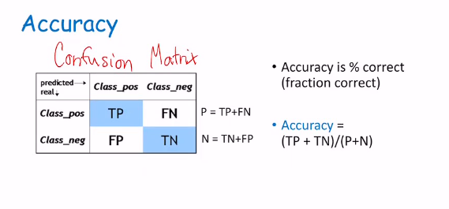

**Discrimination vs detection (spotting)**

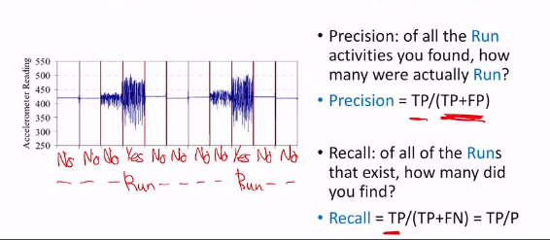

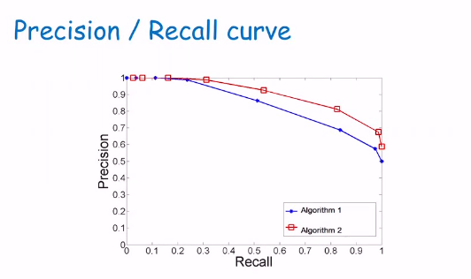

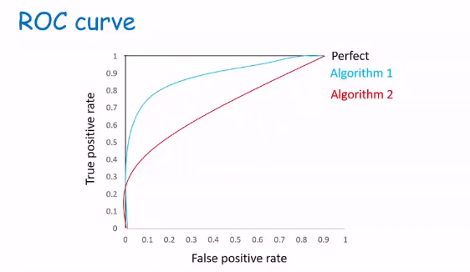

ROC = Receiver Operating Characteristics

ANC = Area Under Curve

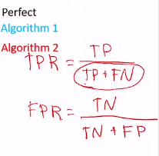

TPR = True Positive Rate

FPR = False Positive Rate

TP = True Positive

TN = True Negative

FP = False Positive

FN = False Positive

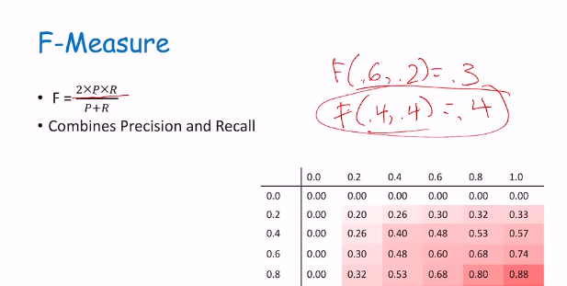

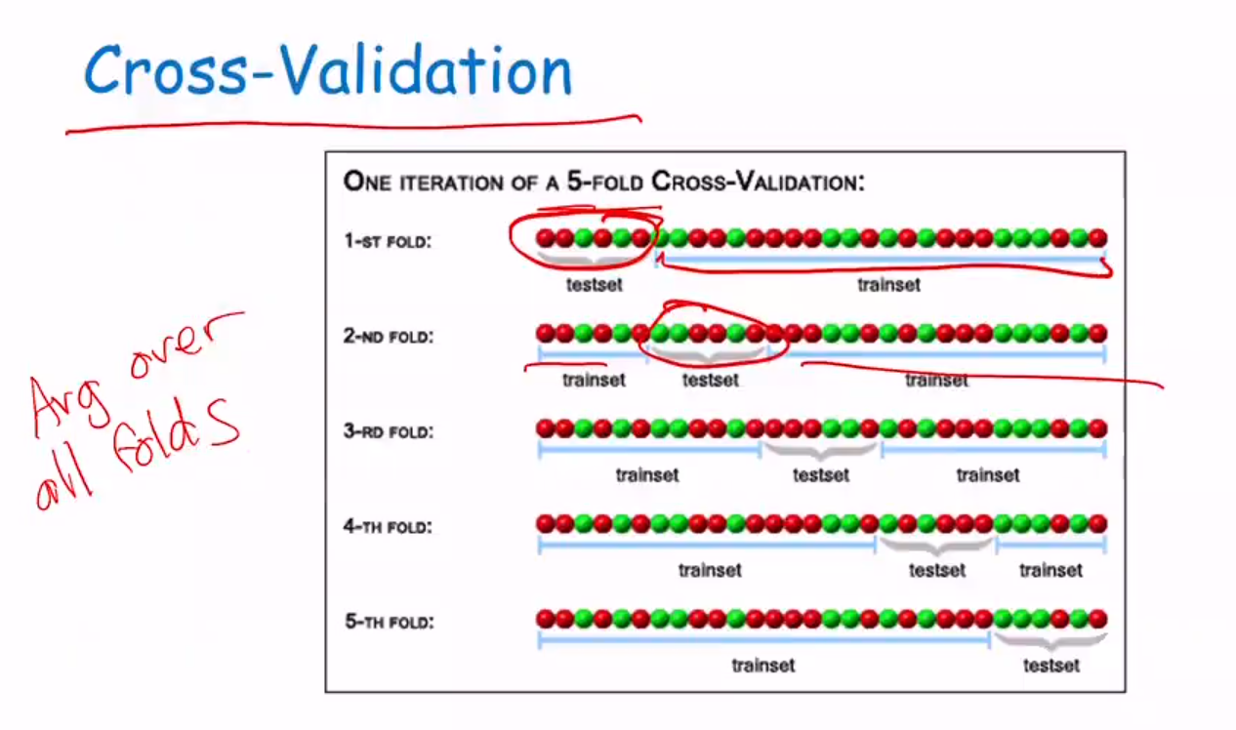

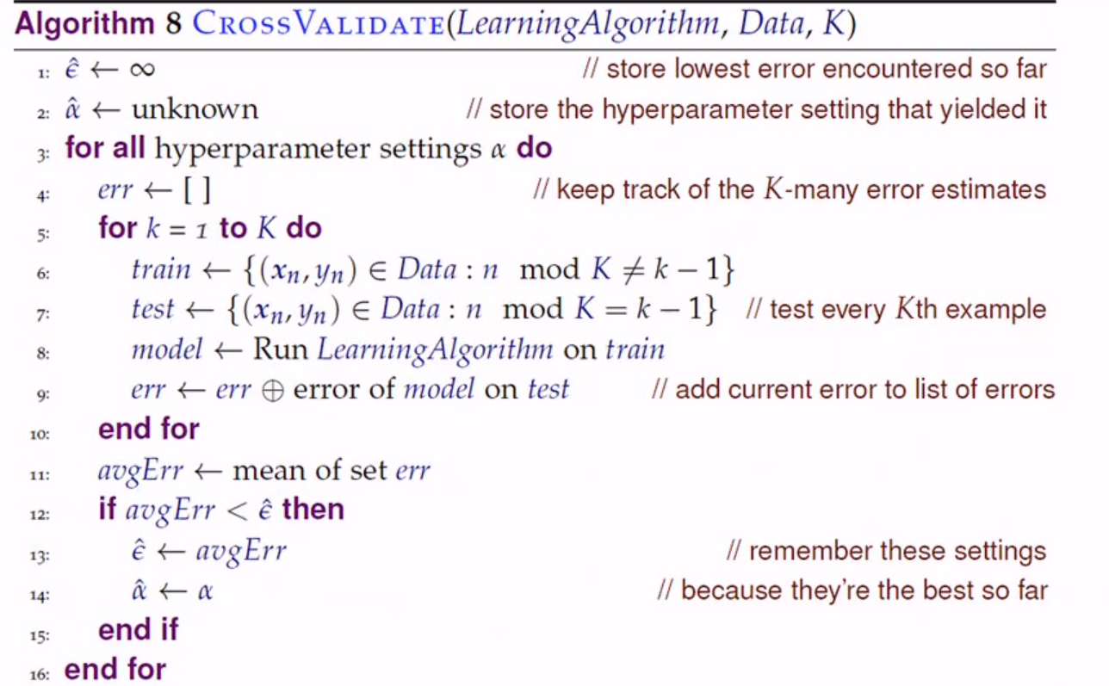

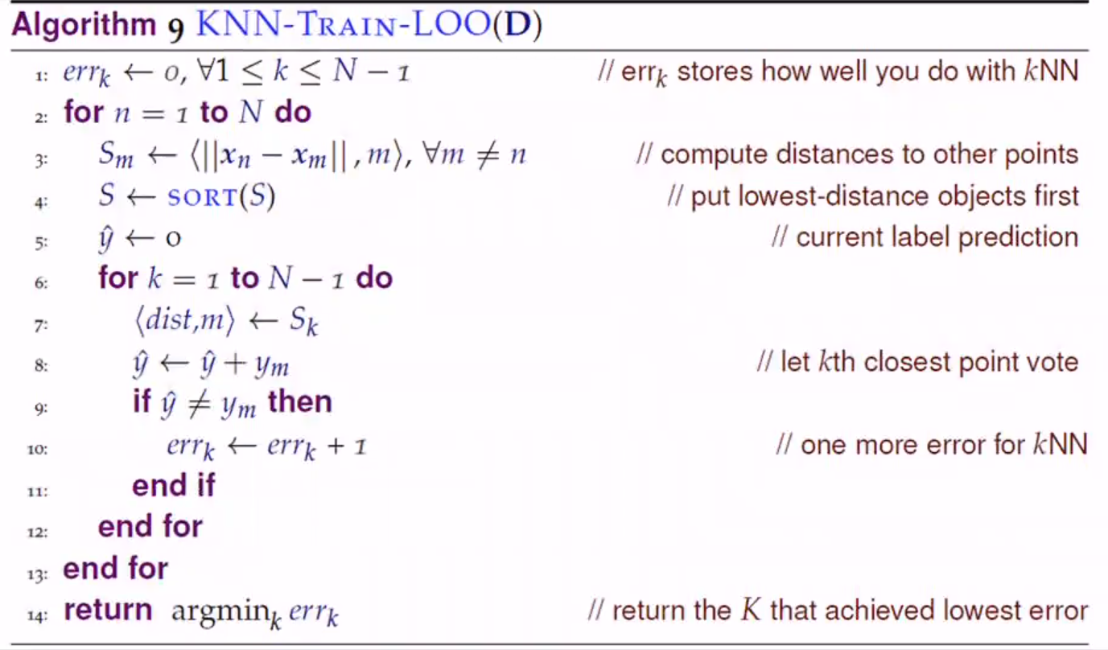

If number of folds = n

Then leave one out (LOO) cross validation